Rig board Specification

# Structure

Entry point

Entry point is from “Rig Board” menu item in main menu.

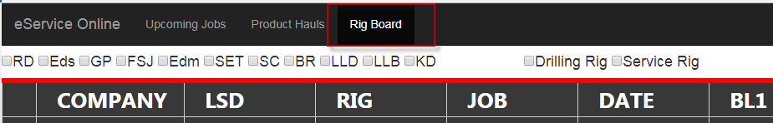

Filter Bar

Filter Bar consists for multiple groups of filter component for dispatcher to easily switch job list between perspectives. It located above data grid.

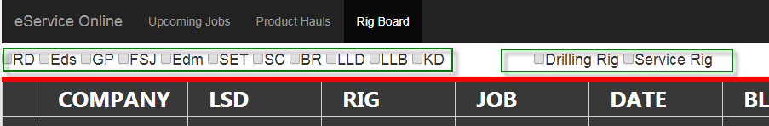

Rig Job List

Rig Job List displays all potential/ongoing/completed jobs and rigs information within Sanjel. Detail information depends on job/rig status.

# General Font & Color Scheme

Background: Dark Grey – RGB (#383838)

Font: Segoe UI Light

Font Size: 22

Font Color:

General - White – RGB (#FFFFFF)

Grid Header Font: Segoe UI Light

Grid Header Font Size: 26

Grid Header Font Weight: Bold

Grid border lines color: Black – RGB (#FFFFFF)

Status Icon: Size 12px X 12 px

Display effect checking device: 60” TV

Separate Line between filter bar and data grid, use the color Pantone 20p C, refer to Sanjel Graphic Standards Manual.

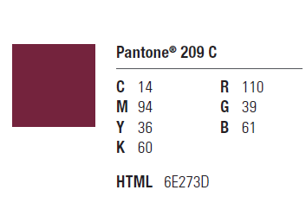

# Column Styles

Column style uses different font color and cell background to indicate corresponding entity status.

## COMPANY – Client Name

Text Display: Use customer short name

Font Color: Regular Customer, White – RGB (#FFFFFF) –

COD Customer, Payment not collected – Use a red exclamation point or some form of subtle alert, not color coding (When mouse hover over to say “COD”)

COD Customer, Payment is collected – Same as above, but use a green check mark as validation of correct information (Hover over to say “COD cleared”)

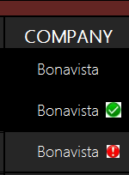

**Behavior:**

1. Right-click on COD Customer with green check mark sign, context menu show “Remove COD cleared”)
2. Right-click on COD Customer with red exclamation point, context menu show “COD cleared”)

**Derived eService User Story****:** Add COD clear flag in Company Information.

In Call Sheet/Job, If a customer is a COD customer, enable a check box called “COD cleared”. Add validation for making call sheet ready.

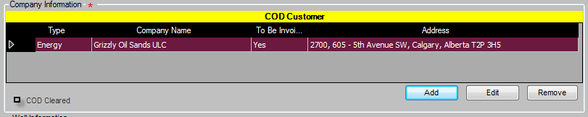

## LSD – Well Location

Text Display: Full location string of down hole well location.

Font Color: Direction is not entered ––Red exclamation mark (Hover over to say “Directions required”)

Direction is entered - green check mark (Hover over to say display directions)

It would be nice if when we change the LSD it prompts us to update directions, or give us the option to keep the same.

Solution:

* When change LSD, Display following fields at same time.
  + Surface Well location Type
  + Surface Well Location
  + Down Hole Well Location Type
  + Down Hole Well Location
  + Directions

*** Direction verification service may be able to integrated with Google Map in future.

**Behavior:**

1. Right-click on LSD, context menu shows “Update Well Location” 和”Update Direction”
   1. 点击“Update Well Location”, pops up update window includes
      * Surface Well location Type
      * Surface Well Location
      * Down Hole Well Location Type
      * Down Hole Well Location
      * Directions

保存时，比较Direction数据是否有改动，如果没有改动，弹出提示框，”Directions is not changed with location change, are you sure to save?”，选择”Yes”继续，选择”No”则继续改动画面。

* 1. 点击”Update Direction”，pops up update window includes Direction only.

Notes：

1. Online中Update Well Location功能，Surface Well Location和Down Hole Well Location目前只提供了一个文本框让用户输入，当Type选择Torren或者NTS时，填写的值在WinForm中是显示不出来的，待分析。
2. 在WinForm有一个Has Downhole选择框，选中之后才可以填写Downhole Well Location的值，Online目前未实现这个逻辑，待分析。

## RIG – Rig Identifier

Text Display: Rig Contractor Short Name (Prefix) + “ “ + Rig Number

Font Color: Top Drive Rig – Red – RGB (#FFFFFF) Instead of colour coding, use an asterix and hover over to say “THIS IS A TOP DRIVE RIG”

OK

Regular Rig – White – RGB (#FFFFFF)

**Derived Master Data User Story:** Create Rig Database

**Derived eService User Story****:** Update Rig information to link up with Rig Database

1. Change Rig Number to Dropdown list
2. Add “Rig Name” textbox , “Is Top Drive” checkbox , Size dropdown list, Thread Type dropdown list
3. Change Rig Contractor, Rig Number as cascading dropdown list, when select a Rig Contractor, Rig Number will populate with the rig number of active rigs in Rig Database, Is Top Drive and Rig Name, Size, Thread Type will be populated.
4. If there is a new rig, user needs to create a new rig from Rig Board before use it.
5. Update rig information, user needs to update an existing rig from Rig Board.
6. Size dropdown list items should be same as following code snippet. (from PlugLoadingHeadInfoPresenter.cs)



1. Thread Type dropdown list items are from CommonApplicationController.DrillingThreadTypes;.
2. .Rig Contractor and Rig Number are only selectable from available items, no new item allowed. Other fields are all read-only.



**Behavior**

Right-click rig identifier, pops up context menu

* Add New Rig. Click to pops up a “Create New Rig” Window
  + Rig Contractor， Rig Size, Size, Thread Type是下拉框，Rig Contrator下拉框需要加自动联想功能
* Update the Rig. Click to Pops up a “Update Rig” Window, Company and Rig Number is not changeable.
* Down for maintenance. Click to change Rig status to “status 2 – Down for maintenance.”
* Down but holding equipment. Click to change Rig status to “status 2 – Down but holding equipment.”
* Down for weather. Click to change Rig status to “status 2 – Down for weather.”
* Down for new lease/licenses. Click to change Rig status to “status 2 – Down for new lease/licenses.”
* Deactivate. Click to change status to “status 3 – Deactivated”
* Activate. Click to change status to “Status 1 – Active”

## 

## JOB – Job Type

Text Display: Job Type Name

Background Color – High Profile Job - Red - RGB(#FF0000) (Need to confirm if this should apply to LSD more properly) Should apply to job type window.

Confirmed

## JOB DATE

Text Display: Different timestamp depends on Job status

Month: use 3 letters abbreviation.

JAN, FEB, MAR, APR, MAY, JUN, JUL, AUG, SEP, OCT, NOV, DEC

DATE列数据的操作：

|  |  |  |  |
| --- | --- | --- | --- |
| 初始状态 | 动作 | 结束状态 |  |
| Alert | Bid Lost | Dropped |  |
|  | Confirmation Call | Confirmed |  |
|  | First Call | Pending |  |
| Pending | Confirmation Call | Confirmed |  |
|  | Cancel Job | Canceled | 目前这个状态没有标识 |
| Confirmed | Reschedule | Confirmed |  |
|  | On Hold | Pending |  |
|  | Cancel Job | Canceled |  |
| Scheduled | Call Out | Dispatched |  |
|  | Reschedule | Confirmed |  |
|  | On Hold | Pending |  |
|  | Cancel Job | Canceled | 目前这个状态没有标识 |
| Dispatched | 目前没操作，这些状态的转换是后台根据数据情况计算出来的。 | | |
| In Progress | 目前没操作，这些状态的转换是后台根据数据情况计算出来的。 | | |
| Complete | 目前没操作，这些状态的转换是后台根据数据情况计算出来的。 | | |

Job Status:

**Alerted:**

Text Display: Estimated Job Date

Font Color: A~~mbe~~r – RGB (#FFBF00) RED – shows date only

**Business Scenario**

Client Solution or client gives a call regarding potential job, the minimum information may only Client name and rough estimated job date, and client may not be current Sanjel client. Temporary client need to be added.

Question: Where should be the entry point? Need to discover further.

**Pending:**

Font Color: ~~Pink~~ – RGB (#FFC0CB) RED – Shows date AND time

**Business Scenario**

A client is called for a job request, detail job information should be entered in call sheet such as client, job type, estimated job date, well location, service point

* Status Condition

In CallSheet->Fist Call, “Expected Time on Location” checkbox is checked. Call Sheet status is In-Progress at this time.

Display Format

Display the time value in textbox after “Expected Time on Location” checkbox

Date (Month in English, date in numeric) + space + Time ( in 24hours format)

Tooltip text: “Job is pending, Expected time on location is {June 20, 10:30}.

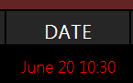

**Confirmed:**

Font Color: Green – RGB (#00FF00) Good

**Business Scenario**

A client is called to confirm a pending job or directly call for requesting a job with confirmation, detail job information should be entered in call sheet such as client, job type, estimated job date, well location, service point

* Status Condition

In CallSheet->Fist Call, “Expected Time on Location” checkbox is unchecked. Call Sheet status is In-Progress at this time.

Display Format

Display the time value in textbox “Requested DateTime”

Date (Month in English, date in numeric) + space + Time ( in 24hours format)

Tooltip text: “Job is Confirmed, expected time on location is {June 20, 10:30}.

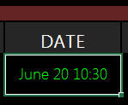

**Scheduled:**

Font Color: Light Blue – RGB (#00FFFF) Good

**Business Scenario**

After a job is confirmed, dispatcher start to fill in necessary information and schedule necessary resources, once all validations are passed, that means the job is properly scheduled.

* Status Condition

In CallSheet->Fist Call, “Expected Time on Location” checkbox is unchecked. Call Sheet status is Reday at this time.

Display Format

Display the time value in textbox “Requested DateTime”

Date (Month in English, date in numeric) + space + Time ( in 24hours format)

Tooltip text: “Resources are scheduled, expected time on location is {June 20, 10:30}.

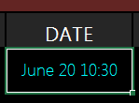

**Dispatched (Called Out)**

Font Color: Yellow – RGB (#FFFF00)

**Business Scenario**

After a job is confirmed, dispatcher start to fill in necessary information and schedule necessary resources, once all validations are passed, that means the job is properly scheduled.

* Status Condition

In CallSheet->Fist Call, “Expected Time on Location” checkbox is unchecked. “Is this call made?” in “Call Information (Call Out) is checked.

Display Format

Display the time value in textbox “Requested DateTime”

Date (Month in English, date in numeric) + space + Time ( in 24hours format)

Tooltip text: “Crew is called out, expected time on location is {June 20, 10:30}.

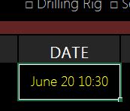

**In Progress**

Font Color: Blue – RGB (#00FF00~~)~~

**Business Scenario**

After a job is dispatched, dispatcher, calls out the crew for executing the job. When field supervisor exports the call sheet to create job, that means the job is getting into operation.

* Status Condition

In CallSheet-> Call Sheet status is Locked at this time. And job package created from this call sheet is not sent to server.

Display Format

Display the time value in textbox “Requested DateTime”

Date (Month in English, date in numeric) + space + Time ( in 24hours format)

Tooltip text: “Job is in progress, expected time on location is {June 20, 10:30}.

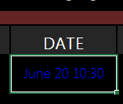

**Completed**

Font Color: White – RGB (#FFFFFF)

**Business Scenario**

After a job is dispatched, dispatcher, calls out the crew for executing the job. When field supervisor exports the call sheet to create job, that means the job is getting into operation.

* Status Condition

In CallSheet-> Call Sheet status is Locked at this time. And job package created from this call sheet is sent to server.

Display Format

Display the time value in textbox “Job Date”

Date (Month in English, date in numeric, year in 4 digits)

Tooltip text: “Job {#456754} has been completed on {June 20, 2017}.

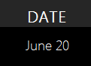

Comments – Confirmed, Scheduled, Dispatched are considered same as per dispatcher’s process today, but they are identified for detail process, we need to implement these status at backend. There may not be a data field in database, however we can calculate these status by the values of certain fields value.

TODO: Detail behavior and status color coding.

## BL1, BL2, BL3

Text Display: Amount of blends required for the job. If there are more than 3 blends, BL3 will display “More”, right click to jump to Blend page for more operation.

**Need A Haul**

Font Color: Amber – RGB (#FFBF00)

This status is determined by the checkbox is checked in Base Blend record, see description below.

**Haul Scheduled**

Font Color: Yellow – RGB (#FFFF00)

This status is determined by “Need A Haul” and Product Load Sheet is created status.

In later phases, here we may implement more in Product Load Sheet and also “Unit& Personnel” section for more status.

当这个Blend被拖运完才认为它是Scheduled。意思是基于Blend创建的LoadSheet总数量大于等于Blend的总数量就认为它是Scheduled。

**On Location**

Font Color: Green – RGB (#00FF00)

This status is determined by on location flag in Product Load Sheet.

当这个Blend的所有LoadSheet都是On Location状态才认为它是On Location状态

**Go with Crew**

Font Color: White – RGB (#FFFFFF)

This status is determined by the check box is not checked in Base Blend record, see description below.

**Behavior**

Mouse hovers over a BL1 or BL2 or BL3 with a number, displays Stage Number, Category, Base Blend Name, Amount, Units and Desity. And bulker/driver, on location time.

Mouse hovers over BL3 with “More”, displays Stage Number, Category, Base Blend Name, Amount, Units and Desity of all blends with in Lead categories, Tail and Plug categories. And bulker/driver, on location time. Exclude the two in BL1 and BL2.

Right-click on the BL fields which with a number, pops up context menu

* Need a haul. Click to flag a haul needed.
  + 如果单元格中显示的是More，Need a haul后面加一个小的红色三角，鼠标指到其上，显示二级菜单，每个菜单项是一个Blend的信息。点击一项之后对该Blend进行Need a haul操作。
* Schedule Product Haul. Click to pop up a window for product haul scheduling, loading sheet created and bulker/driver assigned.
  + 如果单元格中显示的是More，Schedule Product Haul后面加一个小的红色三角，鼠标指到其上，显示二级菜单，每个菜单项是一个Blend的信息。点击一项之后弹出Schedule Product Haul操作页面。

If the click is on BL1 or BL2 or BL3 (with amount displayed), pops up product haul window with Base Blend, Amount, Total Blend Tonnage or Base Blend Tonnage selection populated from clicked cell.

If the click is on BL3 (With “More” displayed”), pops up product haul window as same as current page under “Upcoming Jobs” tab

* On Location. Click to update the selected cell product haul on location status in load sheet.
  + 点击On Location之后弹出框中显示对应的Load Sheet的信息和一个时间控件，和一个保存按钮。
  + 如果单元格中显示的是More，On Location后面加一个小的红色三角，鼠标指到其上，显示二级菜单，每个菜单项是一个Load Sheet的信息。点击一个菜单项之后弹出框中显示对应的Load Sheet的信息和一个时间控件，和一个保存按钮。

*** Comment: 1. After we implement product haul in Rig Board, product haul in Upcoming Jobs page will go away. 2. Assign Driver and Bulker can be separate user story which assign lower priority for now.

Notes：

1. Online目前Need a haul点击后就不能修改Need Haul的标志，如果一个Blend又不需要Haul了该如何处理。如果已经Schedule Product Haul了还是否允许用户修改这个标志？待分析
2. On Location操作，当一个LoadSheet已经进行了On Location操作，那么是否允许它再次点击On Location，修改On Location Time？

**Derived eService User Story:** Flag a haul needed.

1. Add a check box “Need Haul?” to product page for each blend editing page.

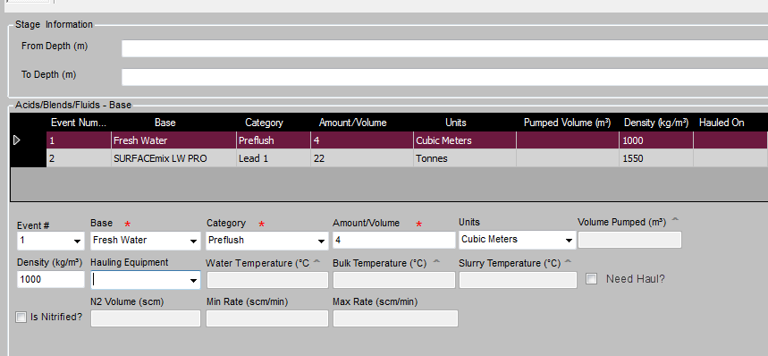

## Notes – Comment notes for material/tools/bins/comments (Need to be break down)

Comments: This information needs to be added to rig job entity database. That means we need rig job database to exist.

**Behavior**

Right-click Notes field, pops up context menu

* Update Notes

Click “Update Notes” , pops up a window “Update Notes”, with only one text area to allow dispatcher to enter notes.

## BANS

Special instructions for Permit, Road BAN, whatever can be digitalized and tracked. Should just be a check box. Specific instructions regarding road bans should be in directions.

????? Need further discussion

Leave BANS out of scope – agreed by Colin, Oct 25, 2017.

## BIN

Text Display: BIN numbers for bins are assigned. “Needed” for bins are needed but not assigned yet.

Bin is assigned and confirmed on location - Font Color – Green – RGB(#00FF00)

Bin is assigned but not confirmed on location - Font Color: Amber – RGB (#FFBF00)

Bin is not assigned - Font Color – Red – RGB(#FFFFFF)

**Behavior**

Right-click Bin Number field, pops up context menu

* Need Bins
* Add a Bin
* Remove a Bin

**Derived eService User Story:** Add bin requirements

1. Add a check box “Need Bins?” and a textbox ”Number of Bins“ to Unit Personnel page Sanjel Storage Equipment section.
2. Add call sheet validation for ready status, to check the number of bins added in Sanjel Storage Equipment meet the needed number
3. 由于Rig Board上Bin列数据的显示状态是根据Bin是否On Location来判断，如果On Location的值不是默认的最小值，则认为它已经On location了，在Winform中允许修改On Location Date/Time的值，但在创建job时不拷贝过去。

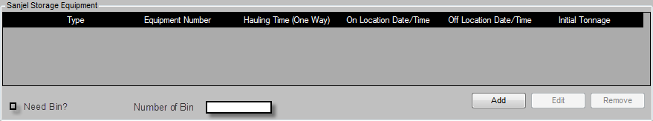

## CONSULTANT CONTACTS

1. 这里获取的值对应eService中以下数据，对吗？

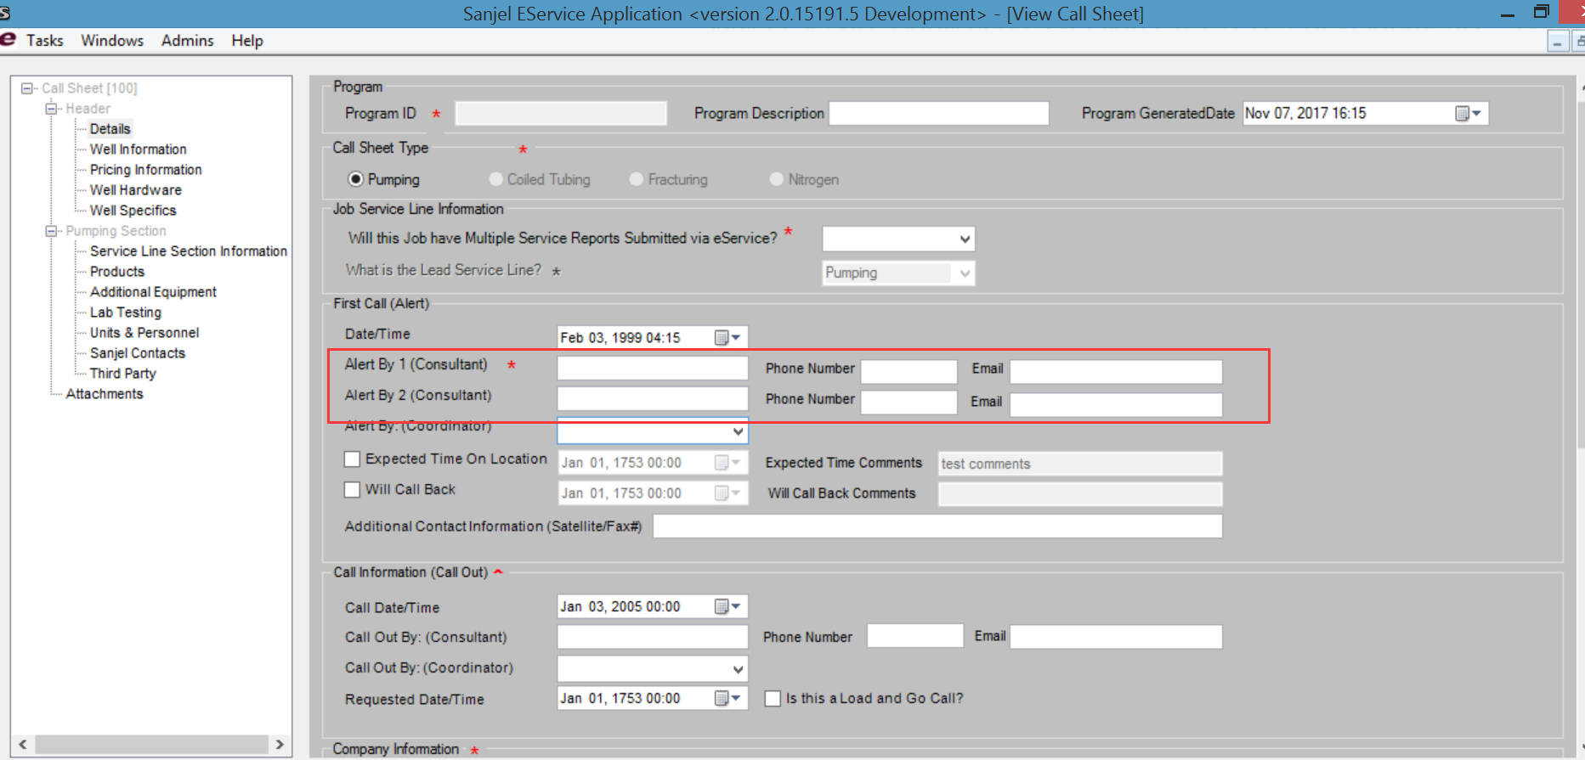

此处”Alert By 1 (Consultant)”, ”Alert By 2 (Consultant)”, ”Calll Out By (Consultant)”, 三行涉及到这个改动。

* 1. 建立Consultant参考数据库，请见新增的脚本。
  2. 建立Consultant数据访问层，服务层CRUD。
  3. 将名字域改为下拉框， 名字由Consultant参考数据，经CompanyInfoSection中的公司过滤，可是多个公司，energy company and consulting company。
  4. 名字域选定一个名字，Phone Number和Email自动填写。填写后可以修改。但不要求存回数据库。
  5. 名字域如果名字不存在，允许输入名字，但只保存在目前的Call Sheet数据库中，不写回Consultant参考数据库，这与eservice中现在的实现是一样的。Call Sheet Header数据库中需要加上ID字段。
  6. 历史数据可以正常加载

1. 本期需求第四条4.Create client consultant database , and hook up with call sheet data entry.包括对Consultant Contacts的CRUD操作，这个操作入口在哪里？需求中未明确。Online中最后一列右侧菜单？

答：在Consultant Contacts这一列选中单元格右击弹出菜单，包括Create New Consultant Contact，Update the Contact，Remove the Contact

1. hook up with call sheet data entry是不是要在eService中Consultant部分的数据改为下拉菜单选择？或者直接从数据库中将数据加载在页面上？
2. Consultant Contacts包括哪些字段

**Behavior**

Right-click Consultant field, pops up context menu

* Add a consultant
  + 只有“Alert By 1 (Consultant)”, “Alert By 2 (Consultant)”这两个，严格按这个次序操作，添加一个时，添到1里，添加第二个时，添到2里，不允许添加第三个。
* Remove the consultant
  + 移除1时，如果有2，则递补进1
  + 如果只有一个值，则不能移除
* Add a consultant
  + 添加一个Consultant到数据库表中
* Update consultant
  + 更新数据库表中该Consultant对应的值

## ROW STYLES

Row style uses row background color to indicate the corresponding rig status

**Active – Pending**

Background-color: Dark-Grey – RGB(#262626)

**Active – In Progress**

Background-color: Black – RGB(#000000)

**Active - Complete**

Background-color: Grey – RGB(#606060)

Again, I am not in favor of this method. I think that we should move rigs that are in Status 2 to a window below. I have attached a mock up that shows my thoughts on this.

**Down**

Background-color: Silver – RGB(#A0A0A0)

Context Menu Styles

当在Rig Board上右键单击单元格会出现右侧菜单，在弹出菜单中，可能会包括两类菜单，一是对当前单元格中的实体对象实例进行操作，如Update the Rig”，是更新这个Rig的信息。二是对当前对象所属的实体类的操作，对”Add A New Rig”。这两类菜单用横线分割开，如下图：

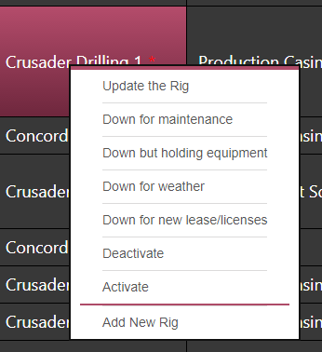

TODO:

1. Scenarios to create call sheet – Not in phase 1 scope
2. Re-organize the coding of rig status.
3. Describe Rig Job entity relationships with Job alert, call sheet, and job.

# Rig Job Data Display

## Rig Job的显示说明1124

1. 每个rig在rigboard只显示一条记录，即最近一个job。
2. 每个rig在rigboard上永不消失，无论状态是什么。
3. Rig job可以强行标志完成，这样后面预设的工作可以显示出来。
   1. Rig board上的排序要求按以下字段的字母顺序进行排序。Company, Rig Name.

## Rig列内容的显示

1. Rig列显示Rig Contrator 对应的Short Name加上Rig Number

Notes： 1124目前可以显示最新添加的数据内容，根据Rig Id获取到公司的Short Name加上Rig Number，但是历史数据该如何处理？以前创建的Call Sheet中只存了Rig Number和Rig Name，没有Rig ID，是否需要将历史数据中的Rig 在Rig数据库中查找，如果查到了将这个Rig对应的ID存到Call Sheet中。